Asia-China-Coin-Round-H 6.7

Early Round Coin (350-220 BCE), round hole, no rim, reverses plain and flat, Obv. Xiang Jin, city in the state of Liang, dia. 3.2cm / 1.26 in., H 6.7 R 4, DCD 617, FD 366.

济阴圜钱, "JiYin"Coin."济阴" Place of Wei Nation while was hold by QI Nation in the warring states period. Now it is the RongHe Town , Shanxi Province. It was made & used in the Wei Nation (403-225BCE), Late Warring States Period. Very Rare.

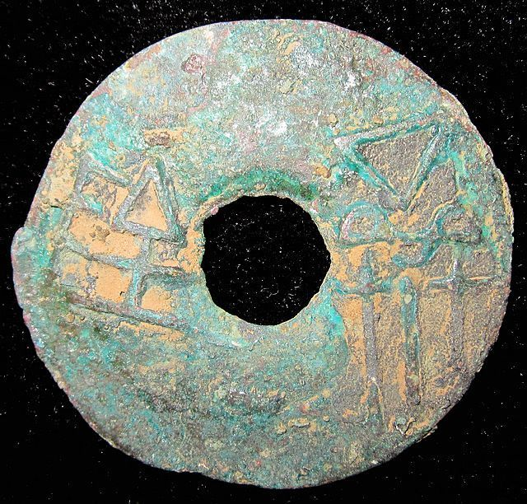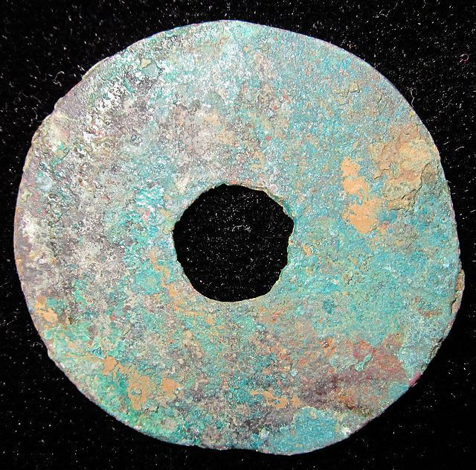

# WarringStatesPeriod WEI NATION WAR CITY MINT MONEY BRONZE ROUND COIN济阴圜钱1.2"RARE

### Seller information

|  |  |
| --- | --- |
|  |  |

[cnrelics](http://myworld.ebay.com/cnrelics?_trksid=p2047675.l2559) ([18](http://feedback.ebay.com/ws/eBayISAPI.dll?ViewFeedback&userid=cnrelics&iid=151193263847&ssPageName=VIP:feedback&ftab=FeedbackAsSeller&rt=nc&_trksid=p2047675.l2560) )

100% Positive feedback

[Follow this seller](http://www.ebay.com/itm/WarringStatesPeriod-WEI-NATION-WAR-CITY-MINT-MONEY-BRONZE-ROUND-COIN-1-2-RARE-/151193263847?nma=true&si=5L4Tlo08dyY9pQflhUEb6fWvMTI%253D&orig_cvip=true&rt=nc&_trksid=p2047675.l2557)

[See other items](http://www.ebay.com/sch/cnrelics/m.html?item=151193263847&nma=true&rt=nc&si=5L4Tlo08dyY9pQflhUEb6fWvMTI%253D&orig_cvip=true&_trksid=p2047675.l2562)

Top of Form

## Item Information

Item condition:

--not specified

“Rust on the body,Museum quality”

Ended:

Dec 27, 2013 05:25:38 PST

Winning bid:

US $49.99

[ [1 bid](http://offer.ebay.com/ws/eBayISAPI.dll?ViewBids&_trksid=p2047675.l2565&rt=nc&item=151193263847) ]

|  |  |  |  |
| --- | --- | --- | --- |
|  | Join **eBay Bucks** and earn **%** back on this item. [See conditionsfor eBay Bucks - opens in a new window or tab](http://pages.ebay.com/rewards/terms.html?ssPageName=STRK:VI:LNLK:TCS) | | |
|  | | New customers get $10 back on 1st purchase Subject to credit approval.[See terms](https://apply.billmelater.com/apply?guid=1SJ8TEIO&assetId=NBRVI1213) |  |

Shipping:

$10.00 Economy Shipping from outside US | [See details](http://www.ebay.com/itm/WarringStatesPeriod-WEI-NATION-WAR-CITY-MINT-MONEY-BRONZE-ROUND-COIN-1-2-RARE-/151193263847?nma=true&si=5L4Tlo08dyY9pQflhUEb6fWvMTI%253D&orig_cvip=true&rt=nc&_trksid=p2047675.l2557" \l "shpCntId)

Bottom of Form